**User guide**

1.3

1.2

1.1

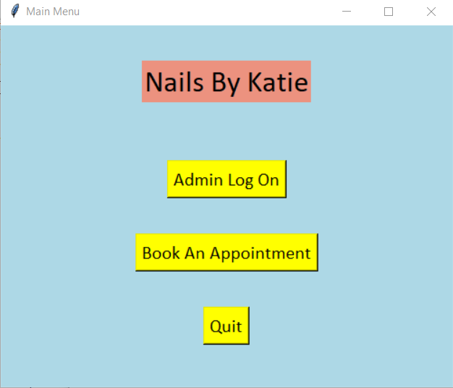

Fig 1

Fig 1 shows the window that t eh user will be first greeted with when opening the program. The menu in fig 1 allows the user to traverse to either the menu in fig 2 or the menu in fig 3. The admin page is for admins and shows analytical aspects as well as a wider view of appointments. Appointment page is for clients of the business where you make, view, and edit appointments.

To move to the admin page, the button ‘Admin Log On’ (1.1) is pressed which opens Fig 2 and closes Fig 1.

Moving to the appointment page requires the user to press the ‘Book an Appointment’ (1.2) button which closes Fig 1 and opens Fig 2.

Pressing the quit button (1.3) will close the program.

2.4

2.3

2.2

2.1

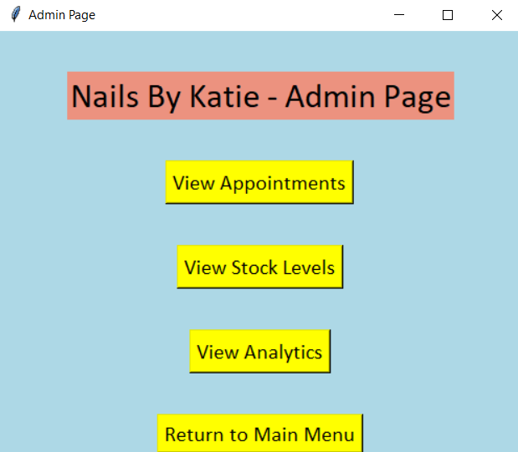

Fig 2

Fig 2 is the result of the ‘Admin Log On’ being pressed. This menu will take a user to each aspect of the analytical side of the program.

View appointment button (2.1) opens a window where the admin can search appointments by names, dates or ID and displays the appointments corresponding to those fields. This window is also where the user would have an option to export to excel to print out their schedule.

View stock levels button (2.2) will open a window which allows the user to type in a product and view the stock level of the program. Pressing the ‘add new product’ button will open a new window where the user can input a product name and a stock level into entry boxes which then get saved to the database. The user can also alter the stock level of a product using entry boxes or buttons and then clicking save.

The button 2.3, View analytics, takes the user to a window which allow them to select a matrix such as popular appointment or client, which then plots the information from the appointment database onto a graph for the user to read.

Return to main menu button (2.4) returns the user to the menu show in figure 1.

After pressing button 1.3 the user is presents with the menu shown in figure 3. This is the menu that is. This menu is the main menu for a client and is where all tasks regarding their appointment would be carried out.

3.2

3.4

3.3

3.1

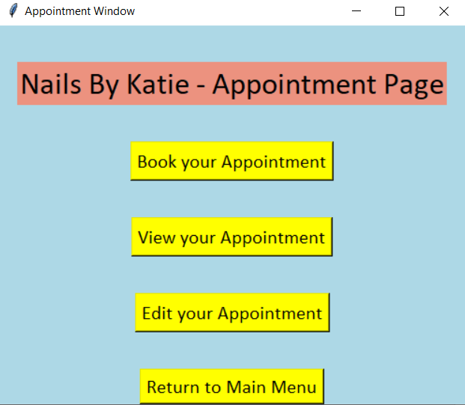

Fig 3

Button 3.1 would take you to figure 4 where a user can enter their corresponding information and book an appointment using the entered information.

Button 3.2 takes you to figure 5, where the user would input a unique ID to view an appointment corresponding to that ID.

Button 3.3 takes the user to figure 7 where the user can alter aspects of their appointment.

Button 3.4 returns the user back to figure 1, the main menu of the program.

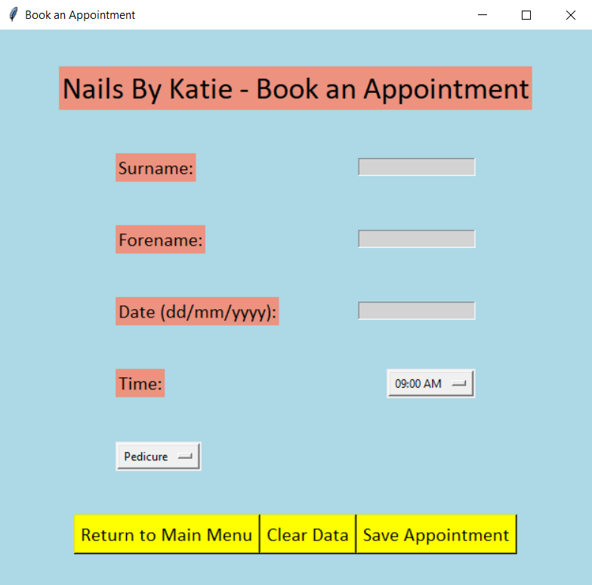

Fig 4

4.1

4.2

4.3

4.5

4.4

4.6

4.8

4.7

This is the window that a client would book an appointment through. The user would input a surname into box 4.1, a forename into box 4.2, a date into box 4.3, select a time from the drop-down menu 4.6 and finally an appointment type from the drop-down menu 4.4. After all this information is inputted, the save appointment button (4.8) is pressed.

Entry box 4.1 and 4.2 follow the same rules of validation. Those being that it must be part of the alphabet, a-z and can’t be a number. The validation also prevents spaces, no entries and only allows 1 hyphen.

Entry box 4.3 validates the date of a user’s proposed appointment.

Figure 9 shows a series of inputs as suggested above. After pressing button 4.8 the appointment is saved, and the user is given an ID which is used to edit and view their appointment. The information entered is validated to ensure that it follows the rules and doesn’t interfere with other appointments.

Fig 9

Figure 10 shows the event of an error and how this is shown to the user. The error message corresponds to the field that failed the validation and then allows the user to alter their information.

Fig 10

Pressing button 4.5 would clear all information. Figure 11 show the result of this button being pressed.

Button 4.7 would allow the user to return to the menu shown in figure 3.

Fig 11

Figure 5 is the menu after pressing button 3.2. this is the view appointment menu where a user would type an ID into entry box 5.1 then clicking on button 5.4 to search and display a corresponding to that ID. An error would be displayed if the appointment didn’t exist.

5.4

5.3

5.2

5.1

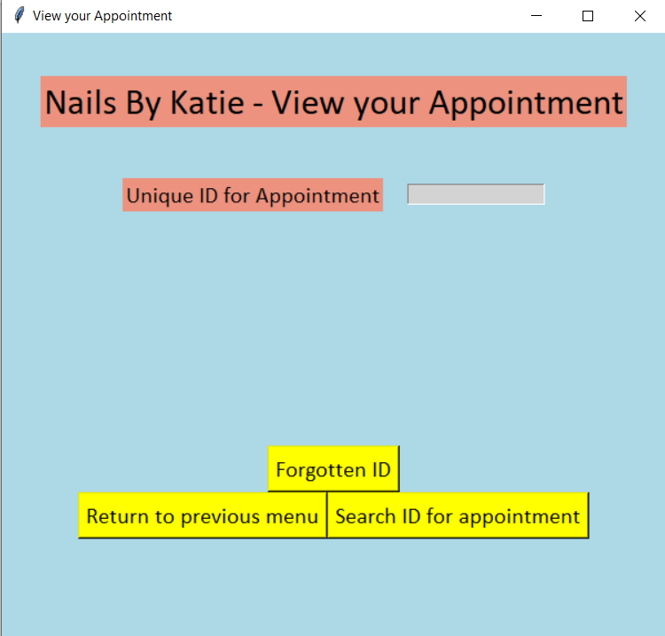

Fig 5

When the appointment Is searched, the ID is validated to ensure it follows certain rules. These rules are only numbers and no spaces. If either of these fails, then an error message will be displayed to the user.

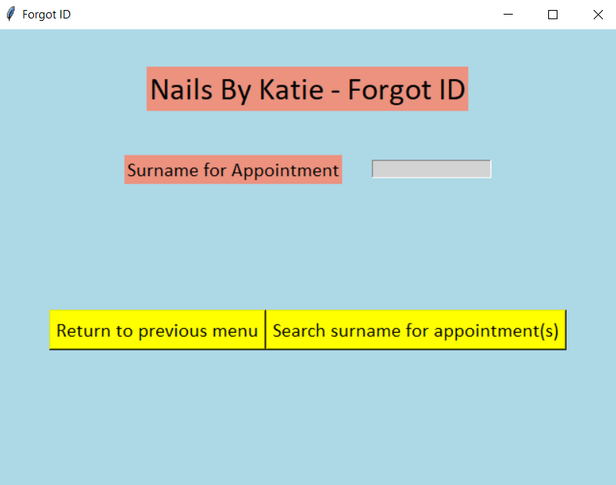

Fig 6

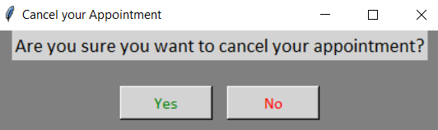

Fig 8

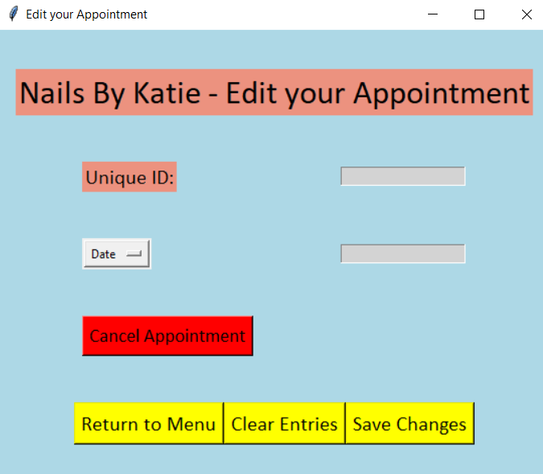

Fig 7